YEAR 7 SCIENCE
EARTH AND SPACE SCIENCES
REVISION - TEST 1

1. Complete the following sentences using the following words.
orbiting, rotation, tides, Moon, tilted, 23.5°, Northern, Southern, gravitational, Hemispheres, spinning, orbit, equator, leap.

(a) Sunrise and sunset are caused by the Earth’s ……………….

(b) The Earth takes 1 year to ……………… the sun once. The orbit is actually 365.24 days in length, which is why most years have 365 days and a ……………… year has 366 days.

(c) The gravitational pull from the moon causes ……………….

(d) A solar eclipse is caused when light from the sun is blocked by the ……………….

(e) The seasons are caused by the Earth ……………… the Sun and being ……………… at an angle of approximately ……………….

(f) Day and night are caused by the Earth ……………… on its axis.

(g) The top and bottom halves of the Earth are called the ……………… and ……………… ……………….

(h) The imaginary line around the middle of the Earth is called the ……………….

(i) The ……………… pull of the moon is one-sixth that of the Earth.

2. Draw a diagram that explains why it is day in Melbourne when it is night in London.

3. (a) Identify which of the pictures below represents summer in Australia and which represents winter.

A 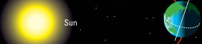 B 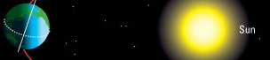

(b) In which months does summer and winter happen in southern Australia?

4. The Antarctic is a unique environment for scientists to work in. There are 6 months of summer in which the scientists have 24 hours of daylight to work in, followed by 6 months of winter when there is no daylight.

Using the diagram from question 3, explain why scientists experience 24 hours of daylight in the Antarctic when it is summer in Australia.

5. When the Apollo 14 mission travelled to the moon in 1971, astronaut Alan Shepard took along a golf ball. He used a rock-collecting tool as a golf club and reported that the ball he hit travelled ‘miles and miles’.

(a) Using your knowledge of the moon’s surface and conditions, explain why the golf ball travelled so far.

(b) Why would Alan Shepard have needed life-support equipment while playing golf on the moon?

6. Label the pictures below to identify the phases of the moon, and then number them to show the correct order of these phases.

(a) (b) (c) (d)
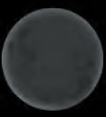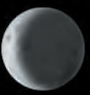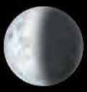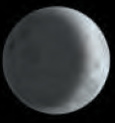
(e) (f) (g) (h)
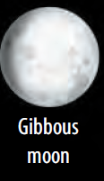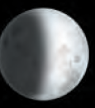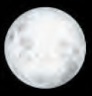

7. Draw a diagram to show how the different positions of the moon, Earth and sun result in a new moon and a full moon.

8. Identify which of the pictures below represents a solar eclipse and which represents a lunar eclipse. Justify your answers.

9. (a) In the diagram below, indicate whether points A, B, C and D are examples of high tide or low tide.

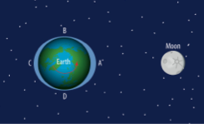

(b) Explain how the Moon causes high and low tides.

10. Indicate on the diagram below where you would expect neap tides and spring tides to occur. Justify your answer.

